Multi-agent Protection Scheme for Microgrid using Deep Learning

Abolfazl Najar, Hossein Kazemi Karegar, and Saman Esmaeilbeigi  
Corresponding author: Hossein Kazemi Karegar

*Abstract*— producing clean energy and feeding critical loads in islanding mode are the main reasons for interest in microgrids. Different operation topologies of microgrids make traditional protection schemes inefficient. This paper proposes a multi-agent protection scheme that can detect different fault events and perform fast isolation for faulty phases. This scheme uses a unique algorithm for determining fault location in microgrids and informs system operators. Microgrids have various operation modes due to the stochastic behavior of distributed generators and different topologies. In this paper, we considered a significant number of operating conditions of the studied microgrid. Different operation conditions of the microgrid are simulated in DIgSILENT Power Factory, and different parameters are stored. Raw measured parameters need to be preprocessed by a signal processing method. Discrete wavelet transform has been chosen for this purpose. It is evident that microgrid protection is a big data problem; deep learning abilities in dealing with big data problems convinced us to use it as our machine learning technique. The proposed scheme performs high accuracy fault detection and fault location in the microgrid. It also ensures system operators for fault isolation in different operation conditions.

*Index Terms*—Deep learning, deep neural network, discrete wavelet transform, fault detection, fault location, microgrid protection, multi-agent protection.

# Introduction

M

ICROGRIDS attracted the attention of the research community and industries in recent years due to distributed generations (DGs) development [1]. Usage of microgrids had increased for its advantages in power systems and the environment. Microgrids can improve the reliability, performance, and stability of power supplying for critical loads.

The presence of DGs next to the power system's demand centers reduces transmission losses, which could be a significant amount of energy in some cases. The presence of DGs in distributed networks changes the energy flow of the system. The power flow of conventional distributed networks is unidirectional, and a fuse or over-current relay can detect fault current. Meanwhile, the presence of DGs on the customer side makes the power flow of the system bidirectional. Besides changing system’s power flow, presence of DGs change characteristic of the power system. DGs have small inertia compared with synchronous generators (SGs); therefore, they should not be expected to participate in frequency control as much as SGs. An inverter between the power supply and grid is essential due to DGs' stochastic production; the inverter controls output voltage and frequency of DG when energy production changes during different situations. The Fault current of DGs is a finite amount in comparison with SGs. In DGs, the fault current is limited up to 2 times of rated current. Meanwhile, the fault current of SGs is directly related to Thevenin impedance is seen by SG; fault current can reach more than ten times SG’s rated current. The diagnosis fault current of SG is more comfortable than the fault current of DGs. Since the fault current of DG is close to the rated current of the system, conventional protection schemes may fail.

The protection of microgrids is one of the significant and critical operational challenges. In recent years, many microgrid protection schemes have been proposed by the research community.

In [2, 3], a communication-based protection scheme is proposed for the microgrid. The scheme considers backup security if the main protection scheme fails.

A discussion about different kinds of fault current limiters (FCL) has been proposed in [4, 5]. They also present the combined protection scheme of FCLs; even though FCL is a suitable tool for reducing DGs' harmful effects, it is not suitable for grids by various topologies.

An adaptive protective system has been presented in [6]. In this scheme, the protection system observes the system continuously, and a new protection setting would be applied by changing the topology. Adaptive protection scheme needs to communication infrastructure to transfer data between protection systems and relays with high security and fast communication rate. Also, microgrid needs digital directional overcurrent relays with the ability to change the setting by remote control. This drawback made us search for another protection scheme.

In [7-10], a differential protection scheme for microgrids has been presented. Impedance-based protection of microgrids is presented in [11, 12]. Details of distance protection for the microgrid are presented in [13]. Also, traveling wave-based protection is introduced in [14, 15]. Impedance and traveling wave-based schemes are not sufficient for microgrids with short distribution lines. Besides, protection schemes using the central processing unit and the differential protection are costly. This kind of protection scheme needs communications infrastructure.

Due to the different topologies of a microgrid and the big data nature of the protection problem, machine learning techniques are used to solve this problem. In [7, 16, 17], decision tree (DT) and random forest (RF) are used for fault detection. Other machine learning techniques such as support vector machine and k-nearest neighbor have been proposed for microgrid protection in [7, 18].

Besides, signal processing methods such as discrete Fourier transform and discrete wavelet transform (DWT) are widely used for preprocessing signals to extract accurate time-frequency characteristics of input signals. Interested readers may refer to [7, 16, 18] to get more information about using signal processing in microgrid protection. In [19], a DT-based fault detection scheme for the microgrid is presented where feature extraction is done by the DWT.

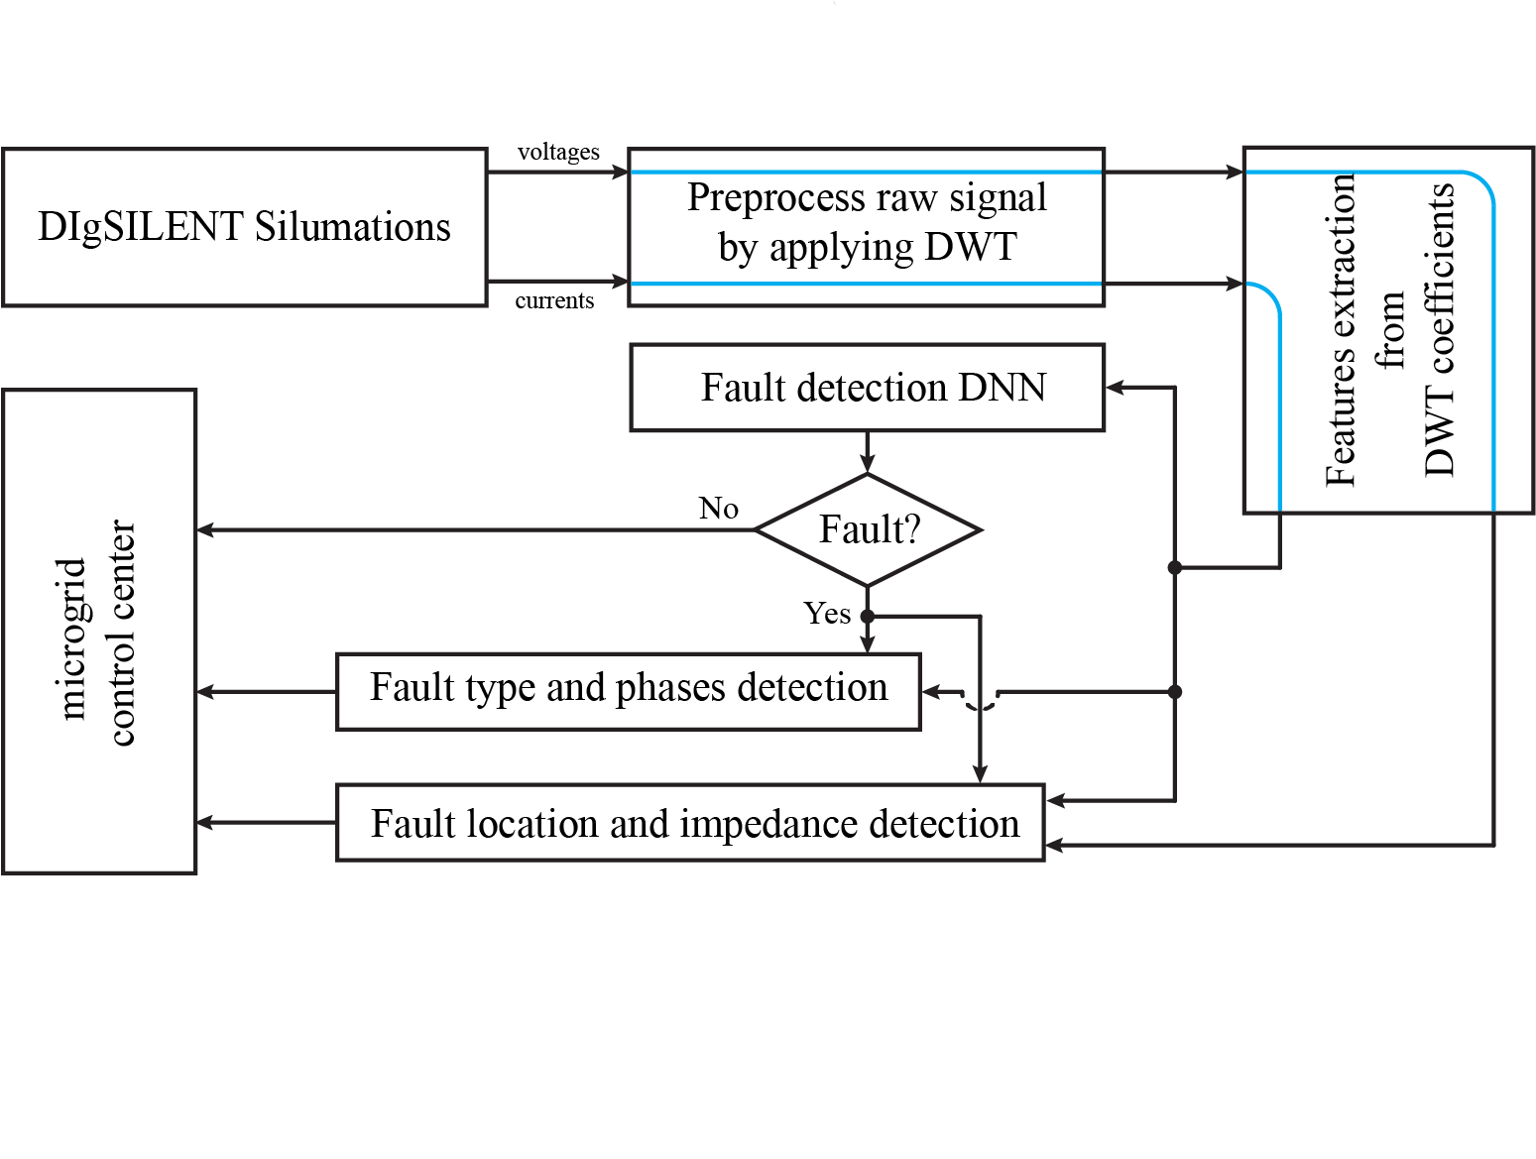

Fig. 1. Schematic diagram of protection scheme.

Esmaeilbeigi et. al in [20] proposed an intelligent scheme based on recurrent neural networks (RNN) and radial basis function (RBF). In this scheme, two laterals in the microgrid are selected to evaluate the results of the proposed scheme. three-phase fault and sequence components currents are used for feature extraction; these data are the inputs of the neural networks to develop fault information. In [21], an intelligent fault detection scheme has been proposed. This scheme uses DWT and deep neural network (DNN) to diagnose different faults on the microgrid.



Fig. 2. CERTS microgrid.

Thanks to the high computational speed of data-driven approaches, fault detection and isolation of faulty phases can be run in near real-time. One of the most important indexes for adequate protection is computation time. The main drawback in machine learning approaches for operational usage is computational time. In this paper, we try to solve the microgrid protection problem with DNN with fewer parameters, making this scheme more efficient in using the same hardware. In this paper, we consider DNN parameters as an index for better performance. Designing a DNN with the minimum number of parameters should be considered for a good protection scheme; meanwhile, the accuracy index is saved or improved.

In this paper, we tried to bridge the research gap in microgrid fault detection; therefore, we present a multi-agent protection scheme in which fault detection on each line would be performed by fault detector agents placed on two sides of a transmission line. We also extract other fault information on the monitoring center of the microgrid. Fig. 1 is a brief schematic diagram of the proposed scheme. This approach uses DWT for its ability of noise suppression. It also helps to solve the sampling window problem of relays. A set of features has been used to extract accurate information on measured parameters. DNN is chosen for its ability to predict system conditions by facing noise. Eventually, with the assistance of mentioned tools, fault information is extracted, and the system operator would be informed about the system's healthiness.

The contributions of this work are summarized as follows:

* We proposed a fault detection algorithm for AC microgrid that diagnosis fault type, fault phase, fault location, fault impedance, and with ability to extract any information of fault
* Performing comprehensive case studies containing possible operation conditions such as lateral branches, high fault impedance, and different DG types.
* Noise suppression with the combination of DNN and DWT. Higher efficiency of the proposed scheme in comparison with other state-of-the-art.
* Using a single DNN for locating faults on all lines and laterals

The proposed scheme can accurately predict fault information (fault type, fault phases) without communication. It helps the system to fast isolation of faulty phases. It also uses a unique algorithm for fault location to predict fault location in different microgrid lines. It can distinguish fault location on lateral branches too.

The rest of this paper is organized as follows. In section II, investigated microgrid has been introduced. Section III gives an overview of the proposed protection scheme in this paper. Different microgrid simulations are explained in section IV, and section V discusses the preprocessing dataset of deep learning. Section VI describes the deep learning-based approach and its properties. Section VII reports the proposed scheme performance and compares it with other state-of-the-art schemes. In section VIII, we conclude this work, and we present references of this work in section IX.

# Investigated Microgrid

This work concentrates on the CERTS microgrid, which has been used in many previous works such as [18], [21], and [17]. Fig. 2 shows the single line diagram of the CERTS microgrid, which has been used to investigate the proposed scheme's performance. The microgrid is operating at 480 V and 60 Hz. The microgrid can supply loads at both islanding and grid-connected modes. In order to generalize microgrid power generation, we considered three DGs. DG-BESS is a battery energy storage system, and DG-PV is a photovoltaic power source. The DGs are connected to the microgrid by using an inverter to convert DC voltage to AC. A synchronous generator is placed in bus 3; DG-SG is a typical diesel generator. A transformer by turn ratio equal to one is placed between DG and microgrid to isolate power supplies and microgrid. DG-PV works as a current control voltage source converter in both grid-connected and islanding modes. In grid-connected mode, DG-PV works as the current control voltage source inverter; meanwhile, by changing the topology of microgrid islanding mode, the control strategy is switched to frequency control inverter. In other words, DG-BESS has responsibility for frequency control in islanding mode.

The values of the microgrid’s parameters are listed in Table I. To investigate the presence effect of lateral branches in this scheme, we added two lateral branches in the middle of lines 12 and 23. These lines have different sizes. At the end of each lateral, an inductive load is placed. Consuming reactive power can cause a voltage drop in the microgrid due to low operational voltage. The nominal demand of loads is mentioned in Table I. For other settings of microgrid, we obeyed from [18].

Microgrids' main ability is maintaining in islanding mode; changing operating mode to grid-connected is possible by closing Point of Common Coupling (PCC) switches. It is available to control microgrid topology by switches between buses 4 and 5. Working on radial or loop topology can be applied based on the operator schedule for the microgrid’s maintenance procedure. The loop switch helps the system operator feed loads by another path in case of causing fault for the main power flow path.

Protective relays placement is described in section III comprehensively. The studied microgrid is simulated in DIgSILENT Power Factory [7]. Since microgrid operation modes are too diverse, extracting parameters for data-mining approaches needs an algorithm for automatically extracting different parameters. To have an automatic algorithm, we use a programming language in DIgSILENT; a code by DIgSILENT programming language (DPL) is used to extract needed parameters.

TABLE I

Element Parameters of Microgrid

|  |  |  |
| --- | --- | --- |
| Element | Parameters | Value |
| Transformers | T-7 | 13.8 kV / 0.48 kV, X/R=6, and Z=5% |
| T-1, T-3, T-6, and T-16 | 0.48 kV / 0.48 kV, X/R=5, and Z=1% |
| Lines | Line 34, Line 56, Line 78, Line 12, and Lateral 12 | Size (AWG2), 68.58 m, Lateral 50% of main line |
| Line 23 and Lateral 23 | Size (AWG00), 22.86 m, Lateral 50% of main line |
| Loads | L-2 and L-4 | 90 kW and 45 kVAR |
| L-5 | 90 kW and -40 kVAR |
| L-8 | 90 kW and -20 kVAR |
| L-12 | 50 kW and 20 kVAR |
| L-23 | 50 kW and 10 kVAR |
| DGs | DG-BESS, DG-PV | 100 kW, unity power factor (3-phase capacitor bank (15kVA)) |
| DG-SG | 100 kW, power factor= 0.8 |

# Proposed Protection Scheme

To build a comprehensive protection method, we should be aware of the weaknesses of protection schemes proposed in previous works. In table II, we list state-of-the-art protection schemes and their characteristics. This table contains two subsections. First, microgrid operation modes are listed; a suitable protection scheme should protect the system during different operation modes. This scheme simulates the imbalance system and DGs variation effect, which were not considered in [21]. Second, we design a protection system that needs no communication to isolate faulty phases; this is an advantage of this work. This protection scheme is a multi-agent approach. We also use the adaptive coordination method to enhance the reliability of the microgrid. We also try to investigate and detect high impedance faults (HIFs) using the proposed scheme. HIFs are hard to detect by conventional methods because, in this kind of fault, the system's voltage and current do not change noticeably.

In table II, EP stands for External protection. In EP approaches additional equipment such as reactances, super-capacitors, or fault FCLs are used to prevent misfiring of protection devices.

The proposed scheme consists of three main subsections. At first, we need to train 3 DNN to extract fault information. To train DNNs, we use DIgSILENT Power Factory to simulate different operation conditions and extract the current and the voltage measurements' values. After measuring parameters, we use DWT to extract features. Signal processing is done in MATLAB R2018b. Finally, to build and train DNNs, we use Python and TensorFlow. Fig. 3 shows a detailed flowchart of the proposed scheme. This flowchart describes a protection system with trained and ready-to-use DNNs. In the first step, one cycle current measured by the line's current relay is used as our protection system's input.

TABLE II

Summary of the main aspects of the analyzed protection schemes

|  |  |  |  |  |  |  |  |  |  |
| --- | --- | --- | --- | --- | --- | --- | --- | --- | --- |
| Analyzed aspect | Protection techniques | | | | | | | | |
| EP | AP | MLFD | | | | | | Proposed scheme |
| [22-24] | [25-29] | [19] | [16] | [30, 31] | [32, 33] | [34] | [21, 35, 36] |
| Microgrid operation |  | | | | | | | | |
| All fault types | Yes | No | No | No | Yes | Yes | Yes | Yes | Yes |
| Imbalance system | Yes | No | No | No | No | No | Yes | No | Yes |
| Load variation effect | Yes | Yes | Yes | Yes | Yes | Yes | Yes | Yes | Yes |
| Dynamic topology | No | Yes | No | No | No | No | Yes | Yes | Yes |
| Grid-connected/islanding-mode | No | Yes | Yes | Yes | Yes | No | Yes | Yes | Yes |
| DGs connect/disconnection | No | Yes | Yes | Yes | Yes | No | Yes | Yes | Yes |
| DGs variation effect | Yes | Yes | Yes | Yes | Yes | Yes | Yes | No | Yes |
| Protection system |  | | | | | | | | |
| One terminal approach | Yes | No | No | Yes | No | Yes | Yes | No | No |
| Non-robust communication systems | Yes | No | No | No | No | Yes | Yes | No | No |
| Adaptive coordination | No | Yes | No | No | No | No | No | No | Yes |
| High-impedance faults | No | No | No | No | Yes | No | No | No | Yes |

We apply DWT and extract features of the measured current. Extracted features are the input of fault type detection DNN. DNN output which is a hot-one vector determines microgrid healthiness or fault situation. The protection scheme continuously checks the output of fault type detection DNN. By detecting a fault in the microgrid, a new procedure will begin. If a three-phase fault is detected in the microgrid, there is no need to run phase-detection DNN. Otherwise, we run phase-detection DNN, and the output of DNN is sent to single-phase beakers of the line to remove faulty phases. By removing faulty phases, microgrid some loads may not be fed. To solve this problem, we feed this fault with another path. By detecting a fault in the microgrid if the fault is not on laterals, we check topology; if the topology is radial, we send a close command to loop switches. This work ensures us to feed loads whose main feeding path has been disconnected. After spending suitable timing, reclosers connect the line to the microgrid. If a fault is detected again, the line would be disconnected. The reclosing operation would be done three times. Otherwise, if the fault remains on the microgrid, the line should be reclosed manually after disappearing the fault. If the fault has been removed from the microgrid by itself, the faulty line will be connected to the microgrid, and the microgrid’s default setting would be applied. The microgrid should be operated in islanding mode by fault on the external grid; in this case, the PCC switches should be open. By changing operation mode to islanding, DG-BESS control strategy changes too. In the CERTS microgrid, the DG-BESS is responsible for frequency control in islanding mode. The control strategy of DG-BESS changes from current control to frequency control in islanding conditions.

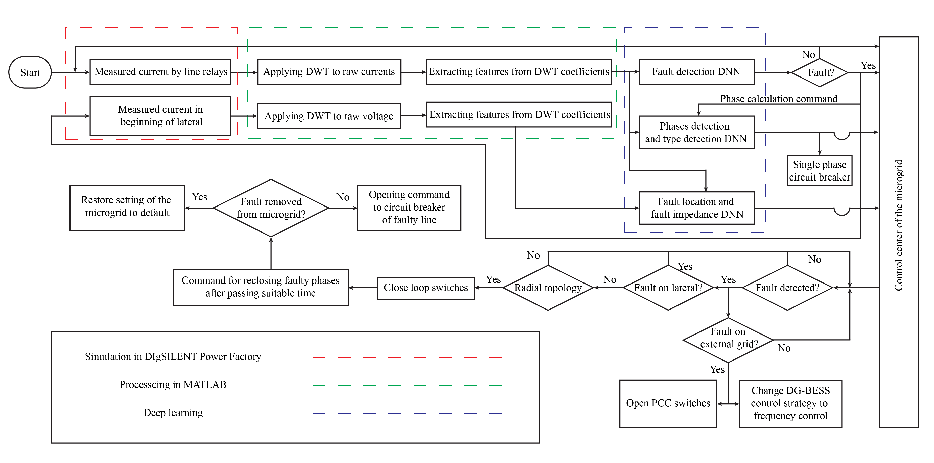

Fig. 3. Detailed flowchart of proposed scheme.



Fig. 4. Relays and measurements placement map in microgrid.

Fig. 4 shows the relay and measurement placement map in the microgrid. In this map, the current of relays specified by red color is used for fault detection. The protection agent processes each relay's current, and after specifying fault on the line, the opening command would be sent to the circuit breaker placed on the same side. On lines with lateral branches, fault on lateral can be detected by relay located on each side of the main line. The trip command will be sent to the lateral circuit breaker to remove the fault. Blue measurements data are continuously sent to the microgrid control center. A computer using all blue measurements tries to locate the fault. Due to the low impedance of the lateral, fault current has a low domain of fluctuation. Therefore, the lateral's fault current has almost the same amplitude by changing location from the beginning of the lateral to the end. Since zero impedance fault on the beginning of lateral, voltage would be zero; while in fault at the end of lateral, the voltage on the beginning side of lateral is not zero, and it depends on lateral impedance and current. Overall, the voltage of laterals is an index with more fluctuation in comparison with the lateral current. This paper measures lateral voltage and sends it to the control center for fault location calculation.

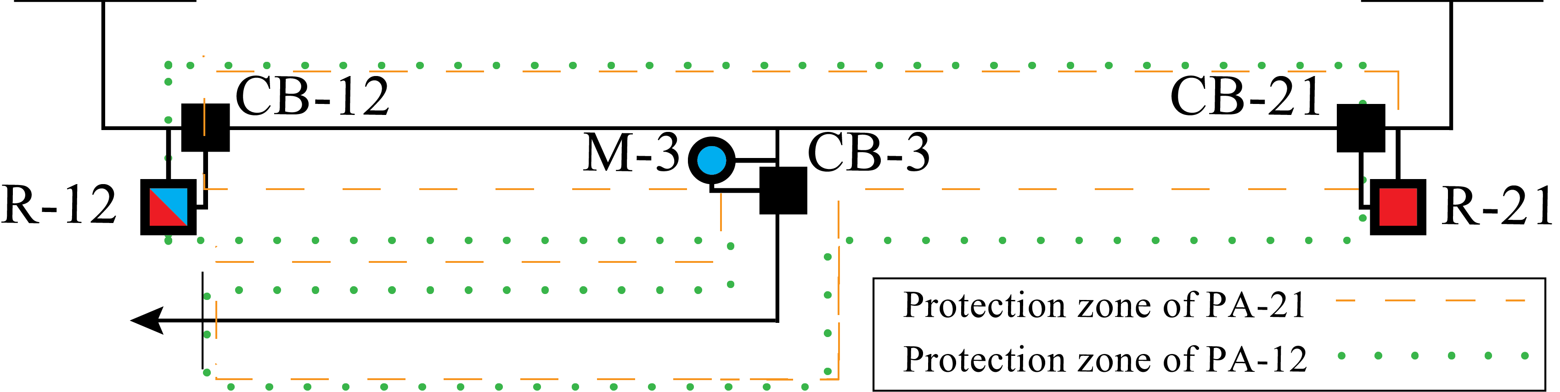

Fig. 6. Protection coverage area for relays on transmission line with lateral branch.

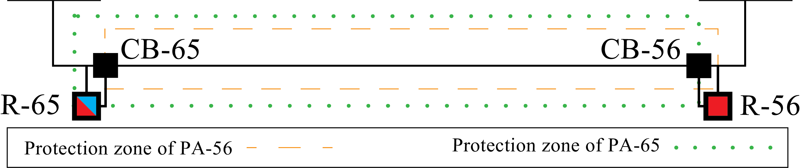

Fig. 5. Protection coverage area for relays on transmission line.

In fig. 5 protection zone of each relay on the transmission line is specified. R-56 can detect all faults on line 56. R-56 sends the open command to the right circuit breaker of the line in case of a fault. R-65 acts the same as R-56; R-65 sends the open command to the left circuit breaker. For reducing protection faults, the open command will be sent from R-56 to CB-65 as backup protection. After two cycles, if R-65 could not make the fault diagnosis on the line, CB-65 will be open by command of R-56. Since fault detection using this approach has high accuracy, using backup protection ensures system operators for fault isolation in the microgrid.

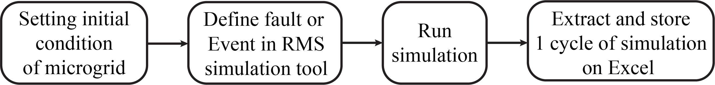

Fig. 7. Schematic of Simulations in DIgSILENT Power Factory.

Fig. 6 shows the protection zone of each relay on the transmission line with the lateral branch. R-12 can detect faults on the main line and lateral. We design a special DNN whose output has two more neurons to fault is located on the main line or lateral. If the fault is on the main line, CB-12 and CB-21 receive the open command from relays. Nevertheless, if the fault is on the lateral, CB-3 receives the control command from R-12 and R-21.

In this scheme, we used three software to design a comprehensive protection scheme. At first, we use DIgSILENT Power Factory to simulate the microgrid in different operation modes. Since the microgrid has various operation cases, we need an algorithm in which different operation cases automatically applied to the microgrid. Also, the current and voltages that we need for train DNNs should be extracted to an excel spare-sheet file. DIgSILENT Programming Language (DPL) helps us to have a code that automatically simulates different operation cases. In this paper, the microgrid parameters in one cycle are measured by the RMS Simulation tool at the DIgSILENT Power factory. In the second step, we need to preprocess raw measurements. Discrete Wavelet Transform (DWT) is used to preprocess measurements. After extracting coefficient series from raw measurement, feature extraction would be done. Six feature is specified for this purpose. All this procedure is done in MATLAB. In the final step, we use Python and TensorFlow to build and train DNNs to complete fault detection and fault location procedure. DNNs are build using the Keras library.

In section IV, simulations of different operation cases of the microgrid in DIgSILENT Power Factory are explained. Section V discuss DWT preprocessing and feature extraction. Section VI demonstrates the structure of DNNs and the procedure to train and evaluate DNNs.

# Microgrid Simulation

All data-mining approaches have an absolute need for a proper database. In this paper, simulations are done in DIgSILENT Power Factory. Microgrids can be operated on different operation conditions, so current flow and amplitude changes can be related to non-fault events. Changing the condition of a load in the microgrid can change the energy flow of lines, and it may be misunderstood with fault events. In order to have a comprehensive dataset, we prepared two sets of configurations. Table III lists configurations for fault events, and Table IV lists configurations for non-fault events. According to These two tables, the microgrid is simulated under different network topologies, different operation modes, and under different events. Overall, 12160 fault cases and 6016 non-fault cases are generated and simulated. These cases are used for the training of DNNs. We also prepare a set of cases in order to evaluate DNNs. These cases are called test cases in data-mining approaches. For producing test cases, the microgrid's initial condition is randomly selected from Table III and Table IV. Only different for fault cases, fault location is chosen randomly between 0 to 100 percent, and for non-fault changing in loads demand are randomly between -20 and 20 percent.

TABLE III

Configuration for fault cases simulation

|  |  |  |
| --- | --- | --- |
| Parameters | Possible configuration | Counts |
| Fault Lines | Line 12-a, Line 12-b, Line 23-a, Line 23-b, Line 34, Line 56, Lateral 12, and Lateral 23 | 8 |
| Topology | Radial or loop | 2 |
| Fault location | 5%, 10%, ..., or 95% on fault line | 19 |
| Operation mode | Grid-connected or islanded | 2 |
| Fault resistance (Ω) | 0 and 1 Ohm | 2 |
| Fault type | (A/B/C)G, AB, AC, BC, (AB/AC,BC)G, or ABCG | 10 |

TABLE IV

Configurations for non-fault cases simulation

|  |  |  |
| --- | --- | --- |
| Parameters | Possible configuration | Counts |
| Topology | Radial or loop | 2 |
| Operation mode | Grid-connected or islanded | 2 |
| L-2, L-4, L-5, L-12, and L-23 | Connected or disconnected | 32 |
| L-8 | Connected | 1 |
| Events | Topology change, operation mode change, L-2, L-4, L-5, L-12, or L-23 load change condition and change demand ±5%, ±10%, ±15%, ±20% | 47 |

Fig. 7 presents a schematic diagram of simulations in the DIgSILENT Power Factory. To simulate mentioned configuration in the microgrid, we use DIgSILENT Programming language (DPL) due to enormous configuration cases. In the first step, the initial condition is set to the microgrid. After that, the event or fault in the microgrid is defined by the RMS simulation tool. RMS simulation is a tool that helps us investigate changes in parameters of the microgrid under a particular event. By running simulation for a specific time, we have access to different microgrid parameters, e.g., line current and voltages. An Excel file is used for storing parameters of the microgrid.

# Preprocessing Datasets



Fig. 8. DWT structure and bandwidth for decomposition

Raw parameters need to be preprocessed by signal processing methods. High-frequency components are produced by happening faults and switching. Therefore, extracting high-frequency components of parameters can help us to detect faults in the microgrid. DWT as a signal processing method has been used in many previous works. In subsection A, we briefly describe DWT and its application in data-mining methods. In subsection B, we describe applying DWT to raw parameters and extracting features for deep learning-based protection.

## Discrete Wavelet Transform

DWT is a signal processing method that decomposes the input time-series signal into an orthogonal set of data. Using DWT, we can extract hidden time-frequency domain characteristics of an input signal. Each level of DWT decomposes the input signal into a high-frequency and low-frequency component. The low pass filter output is called the approximation coefficient, and the high pass filter output is called the detailed coefficient.

Wavelets are zero-mean functions over time [21]. In wavelet analysis, the signal can be decomposed into scaled and translated versions ($ψ_{a,b}(t)$) of a single function ψ $(t)$ called mother wavelet. The relationship is defined as

$$ψ_{a,b}\left(t\right)=\frac{1}{\sqrt{\left|a\right|}}ψ(\frac{t-b}{a})$$

In this relationship, $a$& $b$ are the scale and translation parameters, respectively, and $a,b ϵ R$ and $a≠0$.

The continuous wavelet transform (CWT) of signal s(t) is defined as:

$$C_{a,b}=\int_{-∞}^{+∞}{s\left(t\right)\frac{1}{\sqrt{\left|a\right|}}}ψ^{*}\left(\frac{t-b}{a}\right)dt=〈s\left(t\right),ψ_{a,b}\left(t\right)〉$$

where the symbol $ψ_{a,b}^{*}\left(t\right)$ is complex conjugation of $ψ_{a,b}\left(t\right)$ and ‹› means the inner product. The DWT can be obtained by discretizing the parameters a and b. By defining a=2j and b=k×2j with $j,k ϵ Z$, Eq. (1) can be written as

$$ψ_{j,k}\left(t\right)=2^{-\frac{j}{2}}ψ(2^{-j}t-k)$$

and DWT can be written as

$$d_{j,k}=\int_{-∞}^{+∞}{s\left(t\right)2^{-\frac{j}{2}}}ψ^{*}\left(2^{-j}t-k\right)dt=〈s\left(t\right),ψ_{j,k}\left(t\right)〉$$

Multiresolution decomposition at level H for a given signal s(t) is defined as

$$s\left(t\right)=\sum_{k=-∞}^{k=+∞}{a_{H,k}2^{-\frac{H}{2}}φ\left(2^{-H}t-k\right)+\sum_{j=-∞}^{H}{\sum_{k=-∞}^{+∞}{d_{j,k}2^{-\frac{j}{2}}ψ\left(2^{-\frac{j}{2}}-k\right)≜A_{H}\left(t\right)+\sum_{j=-∞}^{H}{D_{j}(t)}}}}$$

where $a_{H,k}$ is approximation coefficients at level H such that $a_{H,k}=〈s\left(t\right),φ_{H,k}\left(t\right)〉$ And $φ(t)$ is a companion scaling function [37]. Using this transformation, decompose signal s(t) into an approximation coefficient AH and a series of detailed coefficients Dj. The number of the detailed coefficients is equal to decomposition levels (H).

Fig. 8-(a) shows the structure of a three-level DWT, and Fig. 8-(b) shows frequency bandwidth. In this diagram, h0 represents the low-pass filter, and h1 represents the high-pass filter of DWT. Down-pointing arrows denote a decimation or down-sampling by two. DWT has been widely used in fault detection schemes due to its ability to provide various features with optimal time-frequency resolution. The DWT has an essential role in the proposed scheme. Using raw measurements for the input of DNN can cause misleading in the protection scheme by changing in sampling window. Each wavelet has unique time-frequency domain characteristics; therefore, using an appropriate mother wavelet can directly affect the feature extraction ability of DWT.

In order to preprocess measured parameters for fault location DNN, we choose two wavelets. Db2 and sym2 with filter size four and maximum decomposition level of 4 are used for this purpose. The sample number of measurements is 3840/60=64.

## Defining and Extraction of Features

The output of each wavelet is H+1 series of the coefficient which H is decomposition level. Defining a set of features are defined to use them as the input of DNNs. Table V shows features used in this paper. By extracting features from coefficient series, we obtain a vector that is used for the input of DNNs. In Fig. 9 and Fig. 10 extracted features are plotted by fault location and fault impedance, respectively.

# Deep Learning

In this scheme, fault detection on each line is done by fault detection DNN separately. DNN is fed by current relay measurement at one side of the line, and CB next to relay would be informed of fault occurrence. Phase detection is detected by the same method as fault detection. Meanwhile, we use a separate algorithm for fault location determination. Using the current of lines and voltage of laterals as the input of DNN leads us to more accurate fault location determination. Fig. 11 shows the structure of fault detection DNN. This DNN is constructed of the fully connected (dense) layer. Using DNN with fewer trainable parameters can reduce computational time. Fault detection DNN has 15612 trainable parameters and in comparison with DNN in [21], it has much fewer parameters, but accuracy is increased. In Data-mining approaches, using larger models cannot guarantee more accuracy. A similar DNN to fault detection DNN is used for phase detection. The only difference between these DNN is the number of neurons in the last dense layer. The last layer of phase-detection DNN consists of 3 neurons. Each of them represents one of the phases in three-phase system. Fault location DNN is structurally different from the other two DNN. This DNN has different numbers of input. 1156 extracted features are used as input of DNN. The output of DNN is one neuron, and it is a number from zero to one, and it determines fault location on faulty line. The last dense layer's activation function is sigmoid, and for other dense layers, Relu is chosen for this purpose. This DNN is trained for 20000 epochs, and the mean squared error is used as the loss function for optimizing DNN parameters. Adagrad function is used as the optimizer. Depend on the line, the number of output neurons of fault detection DNN is various. For lines with lateral branches, DNN output consists of four neurons. Neurons determine no-fault, fault on the main line, fault on lateral, and fault on other lines, respectively. In [21], each fault detection DNN is trained by non-fault events and fault events of that line; so by happening fault in other lines, fault current can mislead the DNN that fault is happening on the line and this cause not necessary line outage. This problem can critically damage the stability of the microgrid. In this scheme, we also trained other lines’ fault current to this DNN; this ensures that DNN will not be misleading during protection. In the system’s normal operation, the first neuron would be one, and the others are zero. By the presence of a fault, one of the other neurons became one that determines the protection scheme's decision. If the fault is on the main line, circuit breaker of the main line would be open. In faults on lateral, circuit breaker of lateral would be open, and the main line would not be out of service. If the fault is on other lines, there is no need for instant order, but it can be the plan for back up protection.

TABLE V

Configuration for fault cases simulation

|  |  |
| --- | --- |
| Description | Operation |
| The maximum value of the coefficient | Max[s] |
| The minimum value of the coefficient | Min[s] |
| The mean value of the coefficient | $$μ_{s}=E[s]$$ |
| The standard deviation of the coefficient | $$σ_{s}=\sqrt{E\left[(s-μ_{s})^{2}\right]}$$ |
| The skewness of the coefficient | $$E\left[((s-μ_{s})/σ_{s})^{3}\right]$$ |
| The energy of the coefficient | $$\sum{s^{2}}$$ |

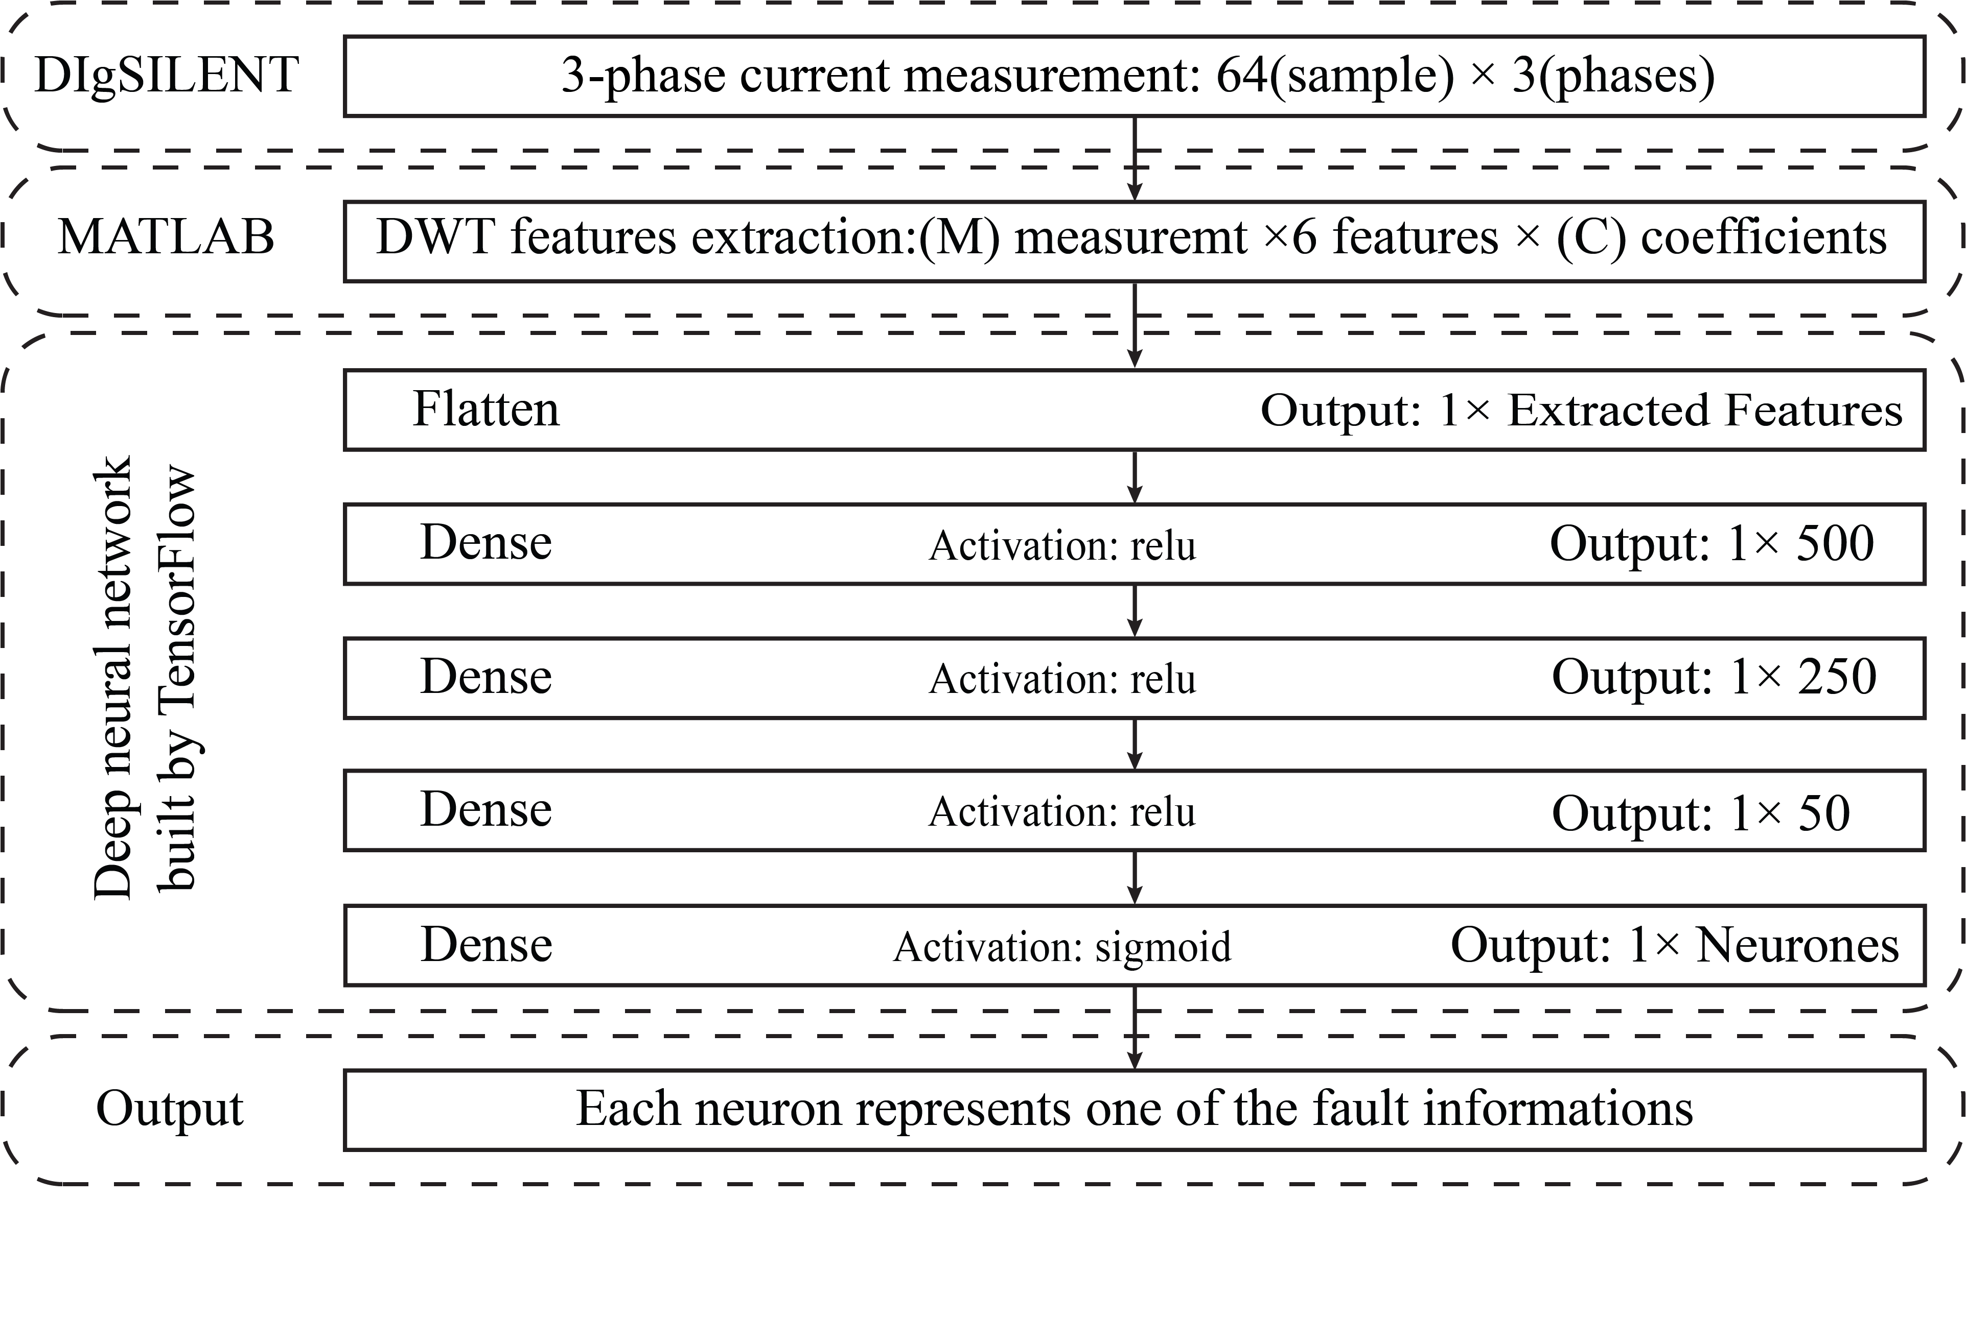

Fig. 11. Structure of fault detection and phase detection DNN



Fig. 10. Diagram of extracted feature by fault impedance

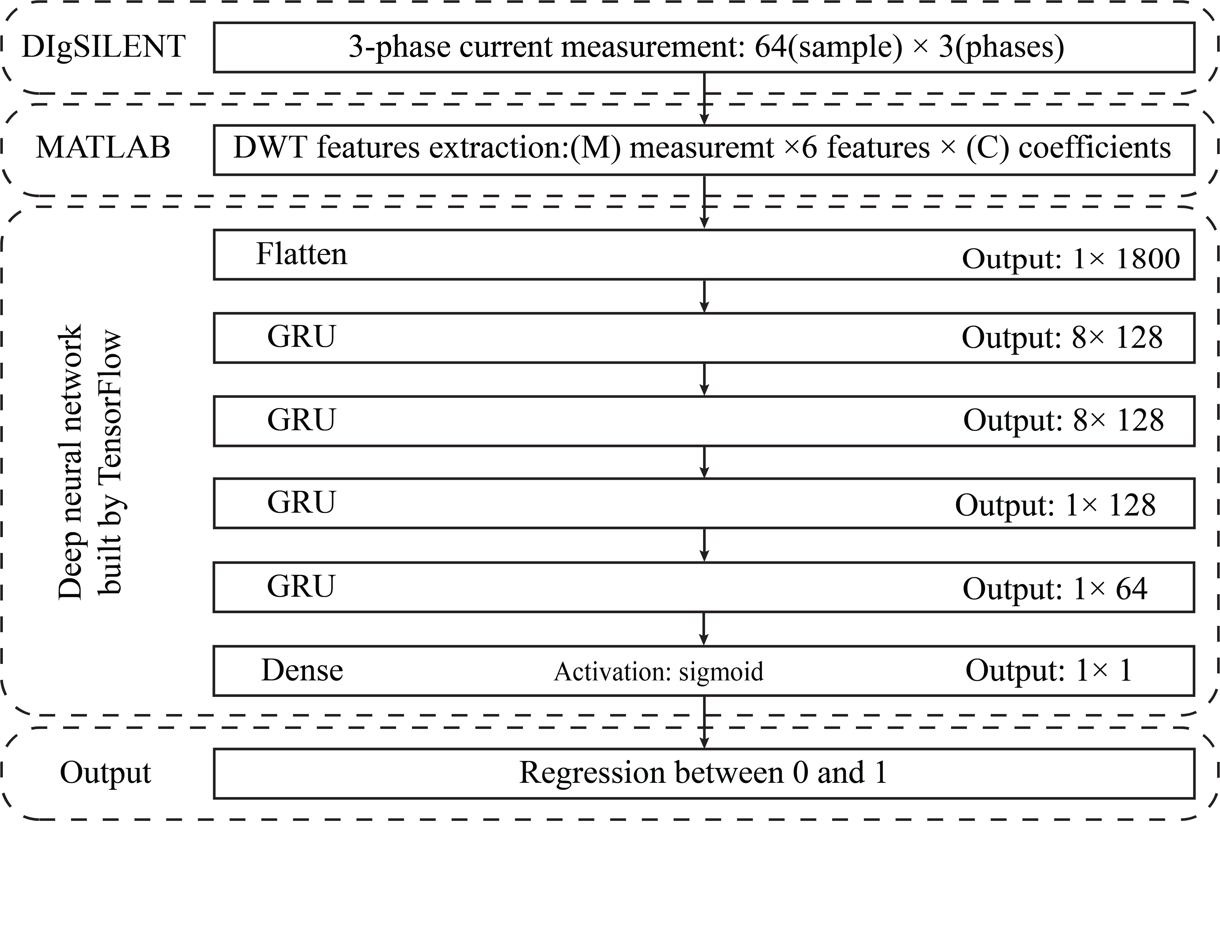

Fig. 12. Structure of fault location DNN



Fig. 9. Diagram of extracted feature by fault location

Fig. 12 shows the structure of fault location DNN. In this paper, fault location would be determined by a single DNN for all lines and laterals of the microgrid. The input of this DNN is 1 × 1800 vector. The output is a regression between one and zero, which determines fault location. Fault detection DNN would detect the fault, and the faulty line name would be sent to the central control unit. Fault location DNN consists of the gated recurrent unit (GRU) and fully connected layer.

Table VI shows detailed information on DNNs which are used for microgrid protection. The responsibility of each DNN is shown in this table. Fault detection, phase detection, and fault location are denoted by FD, PD, and FL, respectively. Fault location DNN would be performed on the device placed in bus 1; this bus is the connection point to the main grid; therefore, this bus has been chosen for placement of FL and FI DNN. In this table, it is shown that each DNN can send the break order to which CB. Protective area and trainable parameters of DNNs are mentioned too. The number of measurements and wavelet coefficient series are denoted by M and C in the table, respectively. The number of training epochs of each DNN is mentioned in this table.

All time-series simulation and processing are conducted on a computer with an Intel Core i5-6400 CPU @ 2.7 GHz and an nVidia GeForce GTX 750 Ti GPU. Time-series simulations are performed using DIgSILENT Power Factory. MATLAB is used for processing data, and DNNs are constructed with TensorFlow.

# Proposed Scheme Performance

In order to compare the proposed scheme with other state-of-the-art schemes, we need to define comparative indices. In this paper, we use four indices to calculate the performance of the proposed scheme.

Accuracy index is defined as the number of correctly classified events by DNN divide by the total number of events. The accuracy index presents an overall review of DNN performance. It is evident by increasing the accuracy of DNN, wrong decisions by DNN will be reduced.

We also define dependability index as the number of detected fault events divide into total fault events. This index is an appropriate source that determines how much protection system commands to circuit breakers are trustable.

Security is another index that is used to report proposed scheme performance. Security index is defined as the number of detected non-fault events divide by the number of total non-fault events. Improvement in this index ensures that the system operator has a protection system with less confusion in detecting non-faults as fault events.

The fourth index is named the error index. This index is defined as the number of wrongly detected non-fault events divide by itself plus the number of detected fault events. In this section, the performance of the proposed scheme is being reported. Table VII represents the fault detection performance of the proposed scheme. The proposed scheme can detect more than 99 percent of events that ensure system operators for effective protection. High security and high dependability show the advantages of the proposed scheme in comparison with other state-of-the-art schemes. The proposed scheme's error index is a minor amount; this index shows that all commands for circuit breakers are genuinely sent.

In Fig. 13 the confusion matrix for DNN 1 is plotted. This confusion matrix shows the performance of fault detection procedure on line 12 and lateral 12 by protection agent 12. Fig. 14 shows the same confusion matrix to Fig. 13 for DNN 9. In this figure, the confusion matrix for DNN 9 is plotted. This confusion matrix shows the performance of fault detection procedure on line 34 by protection agent 34.

Table VIII shows phases and type detection performance. The average accuracy of proposed scheme in phase detection is 99.82 percent, and the average accuracy in fault type is 99.11 percent which confirms the abilities of the proposed scheme. This table contains the accuracy of fault detection, fault type, and phase detection by using the information of each relay. The average accuracy is mentioned in the last row. The proposed scheme Table IX shows the error of fault location DNN in the studied microgrid. Overall, the proposed scheme has only 3.2 percent error in locating fault detection, which is incredibly insignificant due to the short line distance of the microgrid.

$$Accuracy index\left(\%\right)=\frac{number of orrectly classified fault and nonfault events}{Total number of fault and nonfault events}×100$$

$$Dependability index\left(\%\right)=\frac{Number of detected fault events}{Number of total fault events}×100$$

$$Security index\left(\%\right)=\frac{Number of detected nonfault events}{Number of total nonfault events}×100$$

$$Error index\left(\%\right)=\frac{Number of wrongly detected nonfault events}{Number of detected fault events+Number of wrongly detected nonfault events}×100$$

TABLE VI

Detailed information of DNNs

|  |  |  |  |  |  |  |  |  |  |  |  |  |
| --- | --- | --- | --- | --- | --- | --- | --- | --- | --- | --- | --- | --- |
| DNN number | Responsibility | Placement location | Input measurement | Control CBs | Protection Zone | M | C | Input features | Output neurons | Trainable parameters | epochs | Optimizer |
| 1 | FD | Bus 1 | R-12 | CB-12, CB-3 | Line 12, lateral 12 | 3 | 65 | 1170 | 4 | 723504 | 3500 | RMSprop |
| 2 | PD, TD | 3 | 65 | 1170 | 7 | 723453 | 800 | RMSprop |
| 3 | FD | Bus 2 | R-21 | CB-21, CB-3 | 3 | 65 | 1170 | 4 | 723504 | 2200 | RMSprop |
| 4 | PD, TD | 3 | 65 | 1170 | 7 | 723453 | 300 | RMSprop |
| 5 | FD | Bus 2 | R-23 | CB-23,  CB-4 | Line 23, lateral 23 | 3 | 65 | 1170 | 4 | 723504 | 2800 | RMSprop |
| 6 | PD, TD | 3 | 65 | 1170 | 7 | 723453 | 700 | RMSprop |
| 7 | FD | Bus 3 | R-32 | CB-23,  CB-4 | 3 | 65 | 1170 | 4 | 723504 | 1800 | RMSprop |
| 8 | PD, TD | 3 | 65 | 1170 | 7 | 723453 | 300 | RMSprop |
| 9 | FD | Bus 3 | R-34 | CB-34 | Line 34 | 3 | 32 | 576 | 3 | 426453 | 1600 | Adam |
| 10 | PD, TD | 3 | 32 | 576 | 7 | 426657 | 700 | Adam |
| 11 | FD | Bus 4 | R-43 | CB-43 | 3 | 32 | 576 | 3 | 426453 | 1600 | Adam |
| 12 | PD, TD | 3 | 32 | 576 | 7 | 426657 | 500 | Adam |
| 13 | FD | Bus 5 | R-56 | CB-56 | Line 56 | 3 | 32 | 576 | 3 | 426453 | 2000 | Adam |
| 14 | PD, TD | 3 | 32 | 576 | 7 | 426657 | 500 | Adam |
| 15 | FD | Bus 6 | R-65 | CB-65 | 3 | 32 | 576 | 3 | 426453 | 2000 | Adam |
| 16 | PD, TD | 3 | 32 | 576 | 7 | 426657 | 500 | Adam |
| 17 | FL | Bus 1 | R-12, R-21, R-23, R-32, R-34, R-65, M-1, M-2, M-3, M-4 | - | Line 12, lateral 12, line 23, lateral 23, line 34, line 56 | 30 | 10 | 1800 | 1 | 12327425 | 10000 | Adagrad |
| 18 | FI | Bus 1 | 1 | 12327425 | 100 | Adagrad |

For example, for the longest lines of microgrid, e.g., line 34 with the length of 68.58 m, the error in fault location detection is 2.06 percent; it means predicted fault location and actual fault location distance is under 1.41 m. therefore maintenance group should investigate less than 3 meters of the line. Errors in detecting fault locations for different lines are mentioned in Table IX, and the average error is mentioned in the last column. Fig. 15 shows the diagram of predicted fault location by real fault location. To plot this diagram, we used 2000 fault event test data. Each dot presents a fault event. For the ideal fault location scheme, all data should be located on the cyan line; the cyan line represents the mean of the predicted location minus the actual location amount, e.g., location error. We used MATLAB to fit a normal distribution to location error. The mean (μ) amount of location error is calculated -7.77e-4, and the standard deviation (σ) is calculated 0.1028. Table X shows the percentage of location error data which are between different boundaries. For example, 89.55% of location error is between μ + 0.5σ and μ - 0.5σ. This table confirms that a huge amount of location error data is close to zero, which means location error is an insignificant value. In Fig. 16 percentage of fault events is plotted by error of fault location prediction. This figure shows that a huge amount of fault events is predicted by fault detection procedure with error less than 2 percent. This shows that fault location procedure on microgrid lines is working properly, and fault location is predicted accurately for maintenance procedures. On the other hand, the number of events in which fault location is predicted with an error more than 10 percent is almost zero, which means predicted fault locations can be reliable for microgrid maintainers.

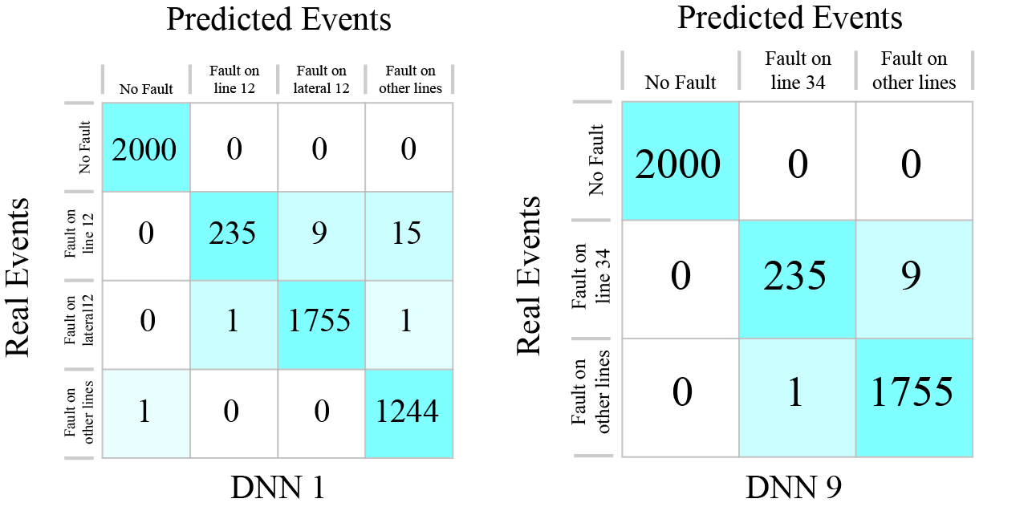

Fig. 13. Confusion matrix for DNN 1

TABLE VIII

Fault Location Error

|  |  |  |  |  |  |  |  |  |  |  |
| --- | --- | --- | --- | --- | --- | --- | --- | --- | --- | --- |
| DNN number | Line | Line 12a | Line 12b | Lateral 12 | Line 23a | Line 23b | Lateral 23 | Line 34 | Line 56 | Average |
| 17 | Train | 0.53% | 0.49% | 0.75% | 2.6% | 1.47% | 3.94% | 0.49% | 0.42% | 1.33% |
| Test | 1.67% | 3.19% | 2.94% | 4.67% | 4.53% | 5.58% | 2.06% | 0.79% | 3.20% |
| 18 | Train | 0.0510% | 0.0511% | 0.0545% | 0.0514% | 0.0521% | 0.0514% | 0.053% | 0.052% | 0.052% |
| Test | 0.0512% | 0.0509% | 0.0509% | 0.0512% | 0.0525% | 0.0512% | 0.054% | 0.051% | 0.051% |

TABLE VII

Fault detection performance

|  |  |  |  |  |  |  |  |  |
| --- | --- | --- | --- | --- | --- | --- | --- | --- |
| DNN number | Accuracy | | Dependability | | security | | Error | |
| Train | Test | Train | Test | Train | Test | Train | Test |
| 1 | 99.22% | 98.88% | 98.84% | 97.80% | 100% | 100% | 0% | 0% |
| 3 | 99.72% | 99.32% | 99.58% | 98.65% | 100% | 100% | 0% | 0% |
| 5 | 99.45% | 99.32% | 99.18% | 98.85% | 100% | 100% | 0% | 0% |
| 7 | 99.27% | 99.10% | 98.91% | 98.40% | 100% | 100% | 0% | 0% |
| 9 | 99.85% | 99.75% | 99.77% | 99.50% | 100% | 100% | 0% | 0% |
| 11 | 99.82% | 99.68% | 99.74% | 99.35% | 100% | 100% | 0% | 0% |
| 13 | 98.83% | 99.50% | 98.35% | 99.00% | 99.87% | 100% | 0.07% | 0% |
| 15 | 99.09% | 99.50% | 98.76% | 99.20% | 99.90% | 99.95% | 0.05% | 0.05% |
| Average | 99.406% | 99.381% | 99.141% | 98.844% | 99.971% | 99.994% | 0.015% | 0.006% |



Fig. 16. Percentage of fault events by prediction error diagram

**

Fig. 15. Percentage of fault events by prediction error diagram

## Comparison to other state-of-the-art schemes

In this section, we compare the performance of the proposed scheme with other state-of-the-art schemes. The results are summarized in Table XI. The scheme with the best result in each section is bolded in this table. The proposed scheme has better performance in comparison with other schemes in all areas. Moreover, the proposed scheme has predicted fault impedance which was unavailable in previous works.

TABLE IX

Fault phases detection and fault type detection performance

|  |  |  |  |  |
| --- | --- | --- | --- | --- |
| DNN number | Phase accuracy | | Type accuracy | |
| Train | Test | Train | test |
| 2 | 100% | 99.50% | 100% | 99.4% |
| 4 | 100% | 99.60% | 100% | 99.35% |
| 6 | 100% | 99.70% | 100% | 99.80% |
| 8 | 100% | 99.90% | 100% | 99.90% |
| 10 | 99.96% | 99.95% | 99.96% | 100% |
| 12 | 99.91% | 99.95% | 99.91% | 99.90% |
| 14 | 99.92% | 99.95% | 99.80% | 99.90% |
| 16 | 99.97% | 99.90% | 99.89% | 99.85% |
| Average | 99.97% | 99.80% | 99.95% | 99.76% |

TABLE X

Phase detection performance

|  |  |
| --- | --- |
| Boundary | Percentage |
| μ - 0.5σ < Data < μ + 0.5σ | 89.55% |
| μ - σ < Data < μ + σ | 93.40% |
| μ - 2σ < Data < μ + 2σ | 96.85% |
| μ - 3σ < Data < μ + 3σ | 97.70% |

We can conclude that the proposed scheme overcomes other fault detection schemes.

# Conclusion

This paper proposed a novel multi-agent scheme that can detect faults in the microgrid with significant accuracy. The proposed scheme predicts fault information such as fault type, fault phases, fault location, and fault impedance. The proposed scheme overcomes the state-of-the-art schemes in many aspects. In this paper, we tried to improve the accuracy of DNN while decreasing the size of DNN. Using smaller DNN helps us to implement DNN on cheaper devices. Using this kind of scheme in reality in microgrids needs to be economically efficient; therefore, we tried to use simpler DNNs. We also reduced the total number of required DNNs that are necessary for microgrid protection.

# References

[1] S. Parhizi, H. Lotfi, A. Khodaei, and S. Bahramirad, "State of the Art in Research on Microgrids: A Review," *IEEE Access,* vol. 3, pp. 890-925, 2015, doi: 10.1109/ACCESS.2015.2443119.

TABLE XI

The proposed scheme accuracy

|  |  |  |  |  |  |
| --- | --- | --- | --- | --- | --- |
| Scheme | Accuracy | | | Error | |
| Fault | Type | Phase | Location | Impedance |
| Proposed Scheme | 99.25% | **99.76%** | **99.80%** | **3.20%** | **0.051%** |
| Wavelet-based DNN [21] | **99.31%** | 97.60% | 97.92% | 5.90% | - |
| Decision Tree [18] | 90.40% | 90.40% | 90.40% | - | - |
| K-nearest Neighbors [18] | 95.63% | 95.63% | 95.63% | - | - |
| Support Vector Machine [18] | 93.30% | 93.30% | 93.30% | - | - |
| Naïve Bayes [18] | 94.24% | 94.24% | 94.24% | - | - |
| Decision Tree [16] | 97.00% | 85.00% | - | - | -- |
| Random Forest [16] | 99.00% | 94.00% | - | - | - |
| Over-current relay [16] | 56.00% | - | - | - | - |
| Differential relay [16] | 96.00% | - | - | - | - |

[2] E. Sortomme, S. S. Venkata, and J. Mitra, "Microgrid Protection Using Communication-Assisted Digital Relays," *IEEE Transactions on Power Delivery,* vol. 25, no. 4, pp. 2789-2796, 2010, doi: 10.1109/TPWRD.2009.2035810.

[3] Y.-S. Oh *et al.*, "Fault detection scheme based on mathematical morphology in last mile radial low voltage DC distribution networks," *International Journal of Electrical Power & Energy Systems,* vol. 106, pp. 520-527, 2019/03/01/ 2019, doi: <https://doi.org/10.1016/j.ijepes.2018.10.035>.

[4] M. Ebrahimpour, B. Vahidi, and S. H. Hosseinian, "A Hybrid Superconducting Fault Current Controller for DG Networks and Microgrids," *IEEE Transactions on Applied Superconductivity,* vol. 23, no. 5, pp. 5604306-5604306, 2013, doi: 10.1109/TASC.2013.2267776.

[5] W. K. A. Najy, H. H. Zeineldin, and W. L. Woon, "Optimal Protection Coordination for Microgrids With Grid-Connected and Islanded Capability," *IEEE Transactions on Industrial Electronics,* vol. 60, no. 4, pp. 1668-1677, 2013, doi: 10.1109/TIE.2012.2192893.

[6] A. Y. Abdelaziz, H. E. A. Talaat, A. I. Nosseir, and A. A. Hajjar, "An adaptive protection scheme for optimal coordination of overcurrent relays," *Electric Power Systems Research,* vol. 61, no. 1, pp. 1-9, 2002/02/28/ 2002, doi: <https://doi.org/10.1016/S0378-7796(01)00176-6>.

[7] E. Casagrande, W. L. Woon, H. H. Zeineldin, and D. Svetinovic, "A Differential Sequence Component Protection Scheme for Microgrids With Inverter-Based Distributed Generators," *IEEE Transactions on Smart Grid,* vol. 5, no. 1, pp. 29-37, 2014, doi: 10.1109/TSG.2013.2251017.

[8] S. Kar and S. Samantaray, "Time-frequency transform-based differential scheme for microgrid protection," *Generation, Transmission & Distribution, IET,* vol. 8, pp. 310-320, 02/01 2014, doi: 10.1049/iet-gtd.2013.0180.

[9] S. Mohanty, J. Mohanta, and A. Gururani, "Microgrid Protection using Hilbert Huang Transform Based Differential Scheme," *IET Generation, Transmission & Distribution,* vol. 10, 07/22 2016, doi: 10.1049/iet-gtd.2015.1563.

[10] D. Okram, D. R. Patnaik, and P. Dash, "Detection, classification, and location of faults on grid-connected and islanded AC microgrid," *International Transactions on Electrical Energy Systems,* vol. 27, p. e2431, 10/02 2017, doi: 10.1002/etep.2431.

[11] S. M. Brahma, "Fault Location in Power Distribution System With Penetration of Distributed Generation," *IEEE Transactions on Power Delivery,* vol. 26, no. 3, pp. 1545-1553, 2011, doi: 10.1109/TPWRD.2011.2106146.

[12] F. M. Abo-Shady, M. A. Alaam, and A. M. Azmy, "Impedance-based fault location technique for distribution systems in presence of distributed generation," in *2013 IEEE International Conference on Smart Energy Grid Engineering (SEGE)*, 28-30 Aug. 2013 2013, pp. 1-6, doi: 10.1109/SEGE.2013.6707931.

[13] Y. Damchi, J. Sadeh, and H. Rajabi Mashhadi, "Preprocessing of distance and directional overcurrent relays coordination problem considering changes in network topology," *International Transactions on Electrical Energy Systems,* <https://doi.org/10.1002/etep.2065> vol. 26, no. 1, pp. 32-48, 2016/01/01 2016, doi: <https://doi.org/10.1002/etep.2065>.

[14] X. Li, A. Dyśko, and G. M. Burt, "Traveling Wave-Based Protection Scheme for Inverter-Dominated Microgrid Using Mathematical Morphology," *IEEE Transactions on Smart Grid,* vol. 5, no. 5, pp. 2211-2218, 2014, doi: 10.1109/TSG.2014.2320365.

[15] S. Shi, B. Jiang, X. Dong, and Z. Bo, "Protection of microgrid," in *10th IET International Conference on Developments in Power System Protection (DPSP 2010). Managing the Change*, 29 March-1 April 2010 2010, pp. 1-4, doi: 10.1049/cp.2010.0209.

[16] D. P. Mishra, S. R. Samantaray, and G. Joos, "A Combined Wavelet and Data-Mining Based Intelligent Protection Scheme for Microgrid," *IEEE Transactions on Smart Grid,* vol. 7, no. 5, pp. 2295-2304, 2016, doi: 10.1109/TSG.2015.2487501.

[17] A. Hooshyar, E. F. El-Saadany, and M. Sanaye-Pasand, "Fault Type Classification in Microgrids Including Photovoltaic DGs," *IEEE Transactions on Smart Grid,* vol. 7, no. 5, pp. 2218-2229, 2016, doi: 10.1109/TSG.2015.2451675.

[18] T. S. Abdelgayed, W. G. Morsi, and T. S. Sidhu, "A New Approach for Fault Classification in Microgrids Using Optimal Wavelet Functions Matching Pursuit," *IEEE Transactions on Smart Grid,* vol. 9, no. 5, pp. 4838-4846, 2018, doi: 10.1109/TSG.2017.2672881.

[19] S. Kar, S. R. Samantaray, and M. D. Zadeh, "Data-Mining Model Based Intelligent Differential Microgrid Protection Scheme," *IEEE Systems Journal,* vol. 11, no. 2, pp. 1161-1169, 2017, doi: 10.1109/JSYST.2014.2380432.

[20] S. Esmaeilbeigi and H. K. Karegar, "Intelligent Fault Detection and Location Scheme for Low Voltage Microgrids based on Recurrent and Radial Basis Function Neural Networks," in *2020 28th Iranian Conference on Electrical Engineering (ICEE)*, 4-6 Aug. 2020 2020, pp. 1-6, doi: 10.1109/ICEE50131.2020.9260904.

[21] J. J. Q. Yu, Y. Hou, A. Lam, and V. Li, "Intelligent Fault Detection Scheme for Microgrids With Wavelet-Based Deep Neural Networks," *IEEE Transactions on Smart Grid,* vol. PP, pp. 1-1, 11/22 2017, doi: 10.1109/TSG.2017.2776310.

[22] H. F. Habib, M. E. Hariri, A. Elsayed, and O. Mohammed, "Utilization of supercapacitors in adaptive protection applications for resiliency against communication failures: A size and cost optimization case study," in *2017 IEEE Industry Applications Society Annual Meeting*, 1-5 Oct. 2017 2017, pp. 1-8, doi: 10.1109/IAS.2017.8101884.

[23] W.-J. Tang and H.-T. Yang, "Data Mining and Neural Networks Based Self-Adaptive Protection Strategies for Distribution Systems with DGs and FCLs," *Energies,* vol. 11, p. 426, 02/13 2018, doi: 10.3390/en11020426.

[24] S. Beheshtaein, M. Savaghebi, R. Cuzner, S. Golestan, and J. Guerrero, "A Modified Secondary-Control Based Fault Current Limiter for Four-Wire Three Phase DGs," *IEEE Transactions on Industrial Electronics,* vol. PP, pp. 1-1, 07/09 2018, doi: 10.1109/TIE.2018.2851970.

[25] C. Yanxia, Y. Xiang-gen, Z. Zhe, and C. Deshu, "Analysis of an Adaptive Overcurrent Relay for Transmission and Distribution Lines," 2003.

[26] P. Mahat, Z. Chen, B. Bak-Jensen, and C. L. Bak, "A Simple Adaptive Overcurrent Protection of Distribution Systems With Distributed Generation," *IEEE Transactions on Smart Grid,* vol. 2, no. 3, pp. 428-437, 2011, doi: 10.1109/TSG.2011.2149550.

[27] O. Núñez-Mata, R. Palma-Behnke, F. Valencia, P. Mendoza-Araya, and G. Jimenez-Estevez, "Adaptive Protection System for Microgrids Based on a Robust Optimization Strategy," *Energies,* vol. 11, 01/25 2018, doi: 10.3390/en11020308.

[28] E. C. Piesciorovsky and N. N. Schulz, "Fuse relay adaptive overcurrent protection scheme for microgrid with distributed generators," *IET Generation, Transmission & Distribution,* <https://doi.org/10.1049/iet-gtd.2016.1144> vol. 11, no. 2, pp. 540-549, 2017/01/01 2017, doi: <https://doi.org/10.1049/iet-gtd.2016.1144>.

[29] S. Kar, "A comprehensive protection scheme for micro-grid using fuzzy rule base approach," *Energy Systems,* vol. 8, no. 3, pp. 449-464, 2017/08/01 2017, doi: 10.1007/s12667-016-0204-x.

[30] S. Kar and S. R. Samantaray, "Combined S-transform and data-mining based intelligent micro-grid protection scheme," in *2014 Students Conference on Engineering and Systems*, 28-30 May 2014 2014, pp. 1-5, doi: 10.1109/SCES.2014.6880053.

[31] M. Mishra and P. K. Rout, "Detection and classification of micro-grid faults based on HHT and machine learning techniques," *IET Generation, Transmission & Distribution,* <https://doi.org/10.1049/iet-gtd.2017.0502> vol. 12, no. 2, pp. 388-397, 2018/01/01 2018, doi: <https://doi.org/10.1049/iet-gtd.2017.0502>.

[32] M. Kavi, Y. Mishra, and M. Vilathgamuwa, "Morphological Fault Detector for Adaptive Overcurrent Protection in Distribution Networks With Increasing Photovoltaic Penetration," *IEEE Transactions on Sustainable Energy,* vol. 9, no. 3, pp. 1021-1029, 2018, doi: 10.1109/TSTE.2017.2759158.

[33] T. Alexopoulos, M. Biswal, S. M. Brahma, and M. E. Khatib, "Detection of fault using local measurements at inverter interfaced distributed energy resources," in *2017 IEEE Manchester PowerTech*, 18-22 June 2017 2017, pp. 1-6, doi: 10.1109/PTC.2017.7981089.

[34] C. Cepeda, C. Orozco, W. Percybrooks, J. Pulgarín-Rivera, O. Montoya Giraldo, and W. Gil González, "Intelligent Fault Detection System for Microgrids," *Energies,* vol. 13, pp. 1-21, 03/06 2020, doi: 10.3390/en13051223.

[35] A. Abdulwahid, "A Novel Approach for Microgrid Protection Based upon Combined ANFIS and Hilbert Space-Based Power Setting," *Energies,* vol. 9, 11/30 2016, doi: 10.3390/en9121042.

[36] O. A. Gashteroodkhani, M. Majidi, M. S. Fadali, M. Etezadi-Amoli, and E. Maali-Amiri, "A protection scheme for microgrids using time-time matrix z-score vector," *International Journal of Electrical Power & Energy Systems,* vol. 110, pp. 400-410, 2019/09/01/ 2019, doi: <https://doi.org/10.1016/j.ijepes.2019.03.040>.

[37] S. G. Mallat, "A theory for multiresolution signal decomposition: the wavelet representation," *IEEE Transactions on Pattern Analysis and Machine Intelligence,* vol. 11, no. 7, pp. 674-693, 1989, doi: 10.1109/34.192463.

# Biographies

**Nikola Tesla** (M’1888, F’17) was born in Smiljan in the Austro-Hungarian Empire on July 9, 1856. He graduated from the Austrian Polytechnic School, Graz, and studied at the University of Prague.

His employment experience included the American Telephone Company, Budapest, the Edison Machine Works, Westinghouse Electric Company, and Nikola Tesla Laboratories. His select fields of interest included high frequency.

Dr. Tesla received honorary degrees from higher learning institutions, including Columbia University, Yale University, University of Belgrade, and the University of Zagreb. He received the Elliott Cresson Medal of the Franklin Institute and the Edison Medal of the IEEE. In 1956, the term “tesla” (T) was adopted as the magnetic flux density unit in the MKSA system. In 1975, the Power Engineering Society established the Nikola Tesla Award in his honor. He died on January 7, 1943.